Substance Use & Mental Health
Access Coalition:
Chapter Awareness Toolkit

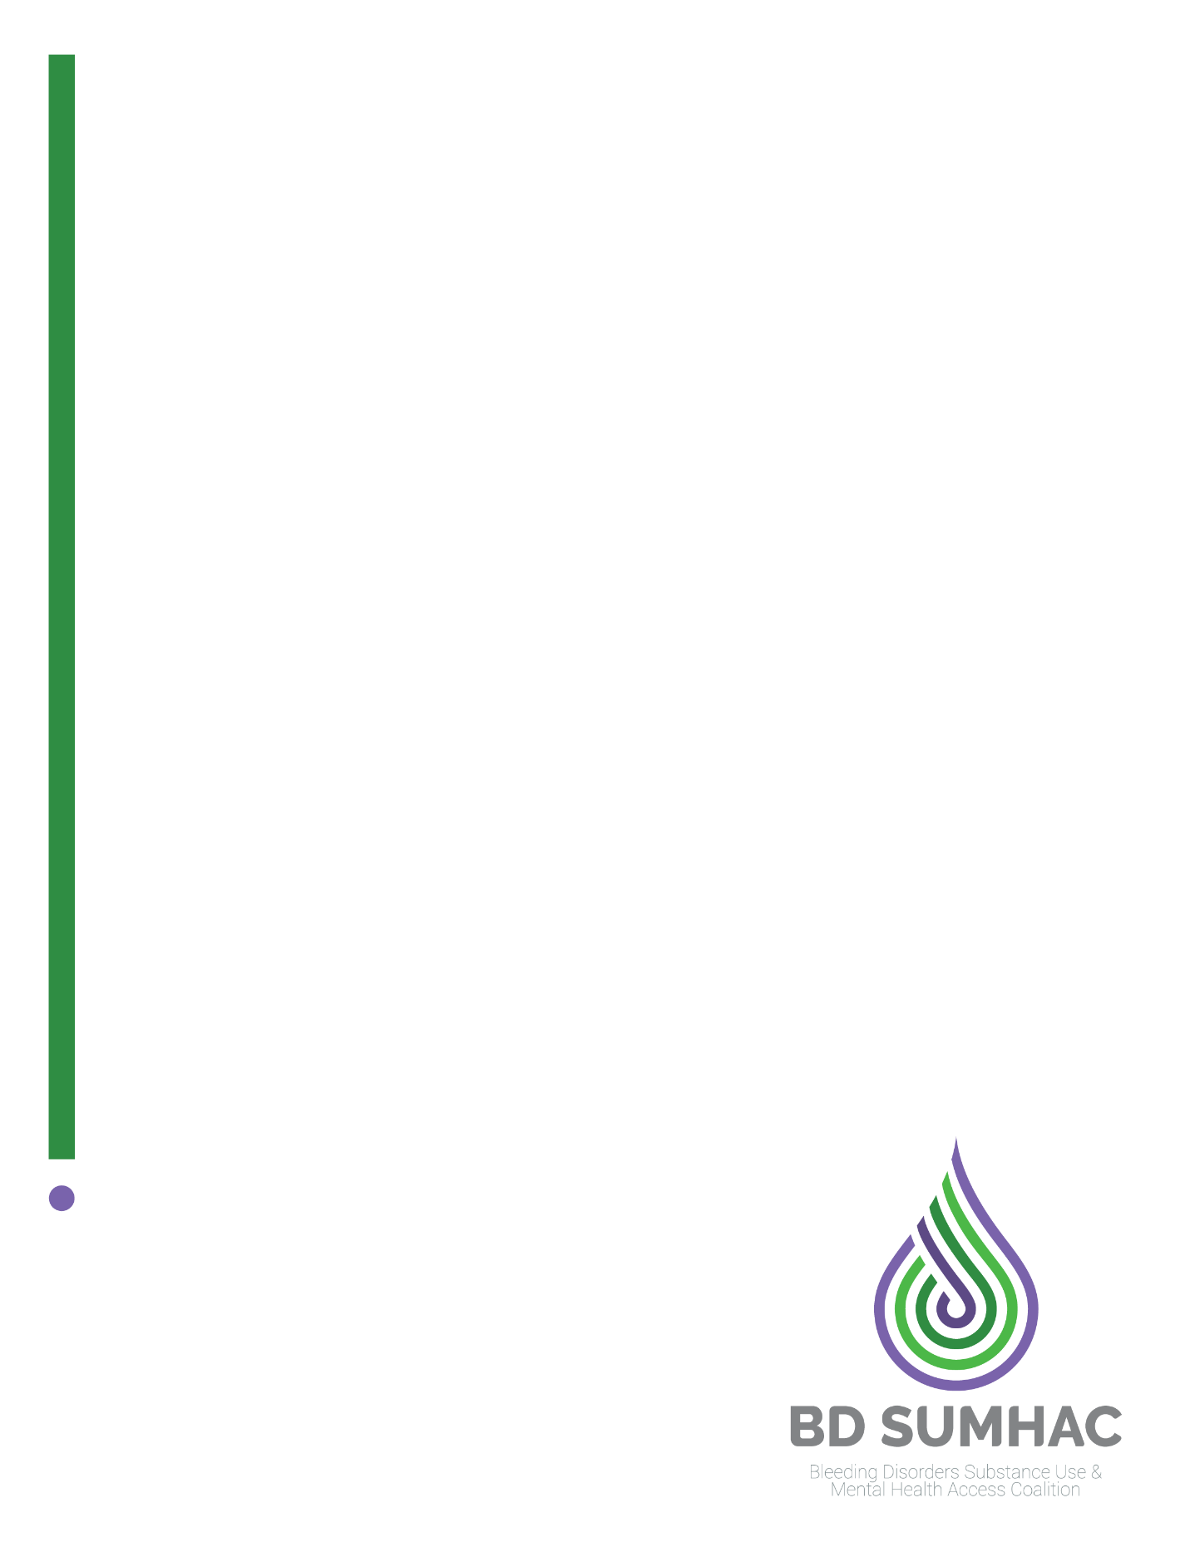
BD SUMHAC Chapter Toolkit

About This Toolkit
This toolkit is designed to make it easy for you to share information and resources related to the Bleeding Disorders Substance Use and Mental Health Access Coalition (BD SUMHAC)’s work to ensure patients with a bleeding disorder have equitable access to mental health and substance use treatment facilities.

Within these pages, you’ll find content and graphics you could share across a variety of communications channels. The point of this content is to be short, to the point, easy-to-absorb, and informative enough to interest the reader and leave them wanting to click/learn more.

Questions about the coalition or the content you see here? Contact the individuals listed below.

______________________________________________________________________________

About the Coalition

In late 2021, a 20-year-old individual from New England with a bleeding disorder asked their hemophilia treatment center (HTC) for help in finding a residential treatment facility for their substance use disorder (SUD). Although the HTC nurse called many local residential SUD treatment facilities, none of them would take a patient with bleeding disorder who required intravenous (IV) infusion medications during their stay. Without access to appropriate treatment, the patient overdosed and died.
After her patient’s death, the HTC nurse contacted NEHA to help ensure that no one else would be denied access to necessary SUD treatment because of their bleeding disorder. Chaired by a board member, NEHA brought together the Hemophilia Federation of American, the National Hemophilia Foundation, HTC providers, other chapters, and bleeding disorder community members to establish BD SUMHAC. The mission of the coalition is to advocate for access to appropriate substance use and mental health treatment facilities for all individuals with bleeding disorders.

___________________________________________________________________________________

Coalition Contacts
The below individuals assist with the Coalition and its efforts. Reach out to them with any questions or needs.

Kate Bazinsky – Coalition Chair - kbazinsky@bdsumhac.org
Ilana Ostrin – Communications Assistant, National Bleeding Disorders Foundation – iostrin@hemophilia.org
Matt Delaney – BD SUMHAC Advocate / Government Relations Specialist, National Bleeding Disorders Foundation – (212) 328-3780, mdelaney@hemophilia.org
Mark Hobraczk – BD SUMHAC Advocate / Senior Manager for Policy, Hemophilia Federation of America – 202-836-2530, m.hobraczk@hemophiliafed.org

__________________________________________________________

Important URLs

Bookmark these URLS to be able to share resources information and easily at any time.

BD SUMHAC Main Page: www.bdsumhac.org

HemAware Article feat. the Coalition: https://hemaware.org/life/behavioral-care-mental-health-crisis

NHF News Article on a Coalition Resource: https://www.hemophilia.org/news/new-document-to-help-residential-substance-use-disorder-placement-for-individuals-with-bleeding-disorders
BD SUMHAC Access Toolkit for people with bleeding disorders: https://www.bdsumhac.org/patient-access-toolkit

BD SUMHAC Provider Toolkit: https://www.bdsumhac.org/provider-toolkit

Stories of people with BD who have experienced mental health/ substance use facility denials: https://www.bdsumhac.org/voices

(*Note about this article: All NHF affiliated chapters are granted permission to share the NHF News or HemAware link digitally, and/or print and distribute the article physically.)

_________________________________________________________________

Example e-Newsletter Content

The below content can be copied and pasted or adapted into your chapter’s newsletter:

eNewsletter Subhead: Get Involved in a New Coalition
eNewsletter Body Copy: Is equitable treatment for mental health or substance abuse crises important to you or your connections within the blood and bleeding disorders community? Then you may be interested in getting involved with Bleeding Disorders Substance Use and Mental Health Access Coalition (BD SUMHAC).

This coalition features members from across the country and a variety of bleeding disorder related groups and chapters, who all unite on one thing: Getting community members the mental health/ substance use disorder treatment they so desperately need, when they need it most.

Learn more about the Coalition here [HYPERLINK TO NEHA PAGE], or explore existing resources like a best practices guide [LINK TO BEST PRACTICES PDF]. Expand your advocacy and spread this important word today!

_________________________________________________________

Example Website Blurb

The below content can be copied and pasted onto your chapter’s website, ideally on a page highlighting resources or ways to get involved with the community:

Web Page Subhead: Advocating for You - Bleeding Disorders Substance Use and Mental Health Access Coalition

Web Page Body Copy: The Bleeding Disorders Substance Use and Mental Health Access Coalition (BD SUMHAC) is a new coalition formed by community members to address the issues of inequitable care facing community members needing residential substance abuse and/or mental health treatment.
The coalition is actively seeking additional supporters who are passionate about advocacy and issues related to mental health and/or substance abuse. Learn more about the coalition and how to get involved here [HYPERLINK BD SUMHAC PAGE].
Get to know about the urgency behind this coalition by reading a personal account of how this issue has impacted the blood and bleeding disorders community [HYPERLINK HEMAWARE ARTICLE].

___________________________________________________________

Example Text Message

We all know those people who only communicate via text message! Copy and paste this quick message into your SMS or iMessage to spread the word that way.
Hi! I know you have an interest in advocacy. Do you have 20 minutes to hop on the phone sometime soon? I’d love to talk to you about a new coalition that is advocating on behalf of the bleeding disorders community for equitable access to residential mental health and/or substance abuse facilities. Let me know if you’re interested in chatting sometime soon – I think you’d be an amazing advocate for this cause!

______________________________________________________________
Example Social Content and Graphics

Copy and paste the below social content to share across your favorite platforms with your network.

Evergreen: What exactly is the Bleeding Disorders Substance Use and Mental Health Access Coalition? Click here to learn more. [BD SUMHAC PAGE HYPERLINK]

Get Involved: Are you a member of the bleeding disorders community who is passionate about advocacy issues related to mental health and substance abuse? Learn about a new coalition and how to get involved! [BD SUMHAC PAGE HYPERLINK]

Share Best Practices: The Bleeding Disorders Substance Use and Mental Health Access Coalition has put together some best practices for helping individuals access residential treatment facilities for substance abuse and/or mental health. Share these with your HTC providers today. [BEST PRACTICES PDF LINK]

Share HemAware Article: Adolescents in the blood disorders community who have mental health problems often face added barriers to accessing behavioral health care. Learn more about this issue that inspired the formation of a new coalition in a HemAware article. [HEMAWARE ARTICLE LINK]

Graphics: Right click and download these images to save them to your computer and use them for sharing purposes. If you are unable to do so, please email iostrin@hemophilia.org and request images to be emailed to you.
Evergreen/Get Involved Graphics:
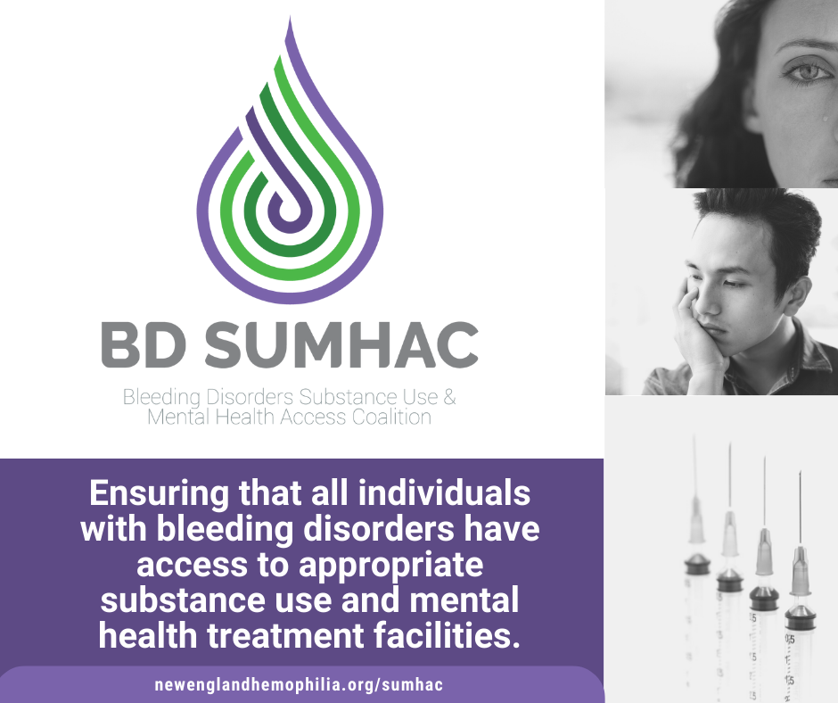

(Recommended for Twitter or Email Banner Sizes)
